C:\Users\Admin\ffmpeg-master-latest-win64-gpl-shared\ffmpeg-master-latest-win64-gpl-shared\bin

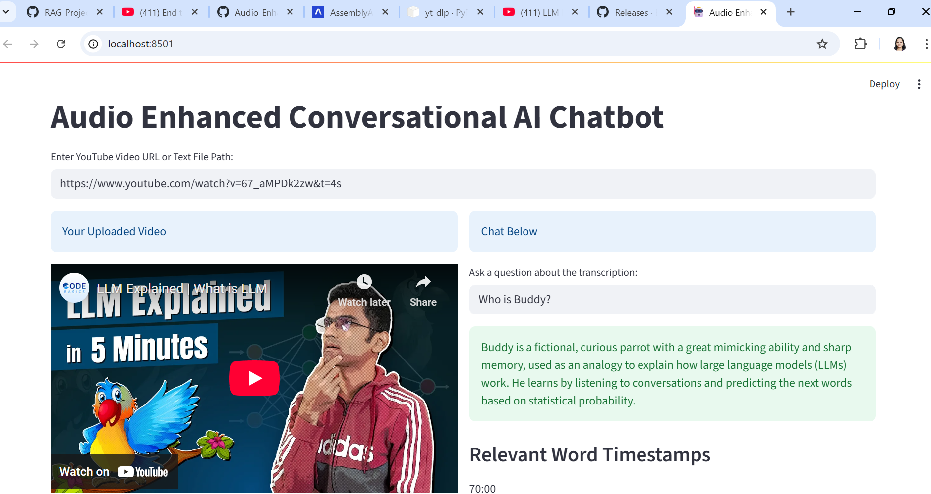

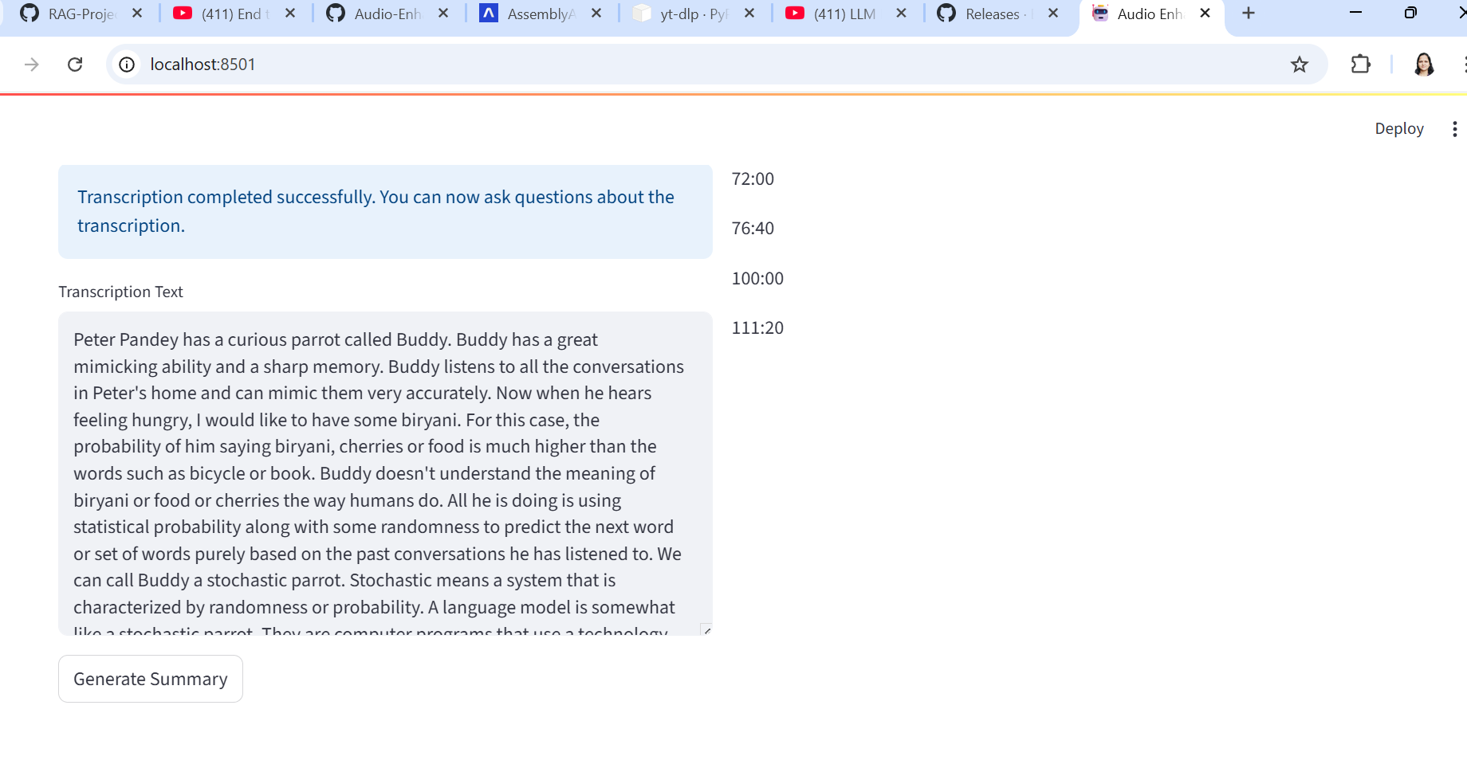

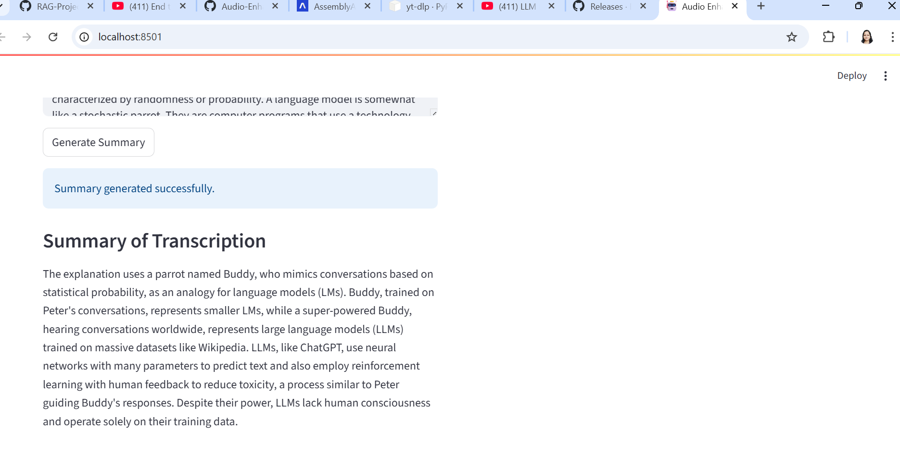

Here are some tailored and creative project title suggestions that align beautifully with the scope and functionality of your tool:
🎯 Practical & Professional Titles
- VidQuest AI: Semantic Retrieval and Chatbot System for YouTube Videos
- YTInsight: Transcript Summarization and RAG-powered Conversational Agent
- YouSummarize: End-to-End Video Understanding with Gemini-powered Retrieval
- TranscriptoRAG: Video Transcript Summarization and RAG-based Chatbot using Gemini
💡 Creative & Catchy Titles
- TubeSage: Your Smart Companion for Summarizing and Conversing over YouTube Content
- EchoBot: Listen, Learn, and Talk with YouTube—Powered by Gemini
- ClipQuery: Conversational Intelligence over Video Content with Timestamped Retrieval
- DeepDiveTube: From Transcription to Query—Your Personal AI for Video Exploration
🔍 Academic or Research-Oriented Titles
- Multi-Modal Semantic Understanding of YouTube Videos Using Gemini LLM and RAG Retrieval
- End-to-End Conversational RAG Framework for Video Transcripts with Timestamp-based Evidence Extraction
If you’re showcasing this as part of your portfolio or certification, you might want to emphasize either the technical depth (e.g. Gemini, RAG, chatbot NLP) or user-centric aspects (e.g. summary generation, timestamped content delivery). Want me to help tailor one for your resume or GitHub?

